PH30028: Soft Condensed Matter Physics

Outline solutions to problems

(1) Relaxation time in atomic fluids

Brownian motion:
displacement 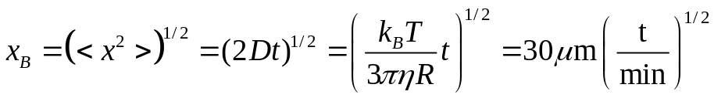
and thus in 1 min: 30 μm and in one hour: 229 μm

Sedimentation:
displacement: 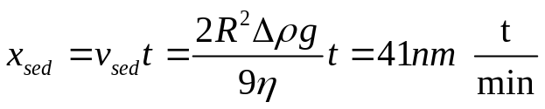
and thus in 1 min: 41 nm and in 1 hour 2.5μm

(2) Equipartitioning
Equipartitioning: 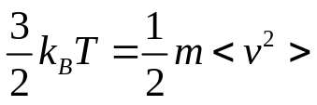
and thus
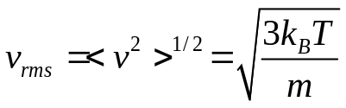
and relaxation time

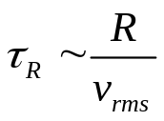
Example:
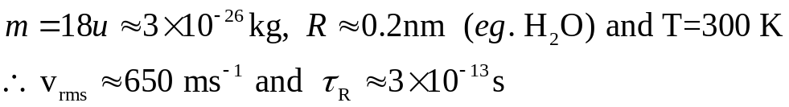

(3) Gravitational length
- Distribution of particle number: 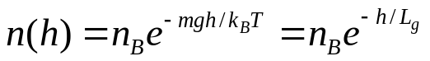 where the `gravitational length’ 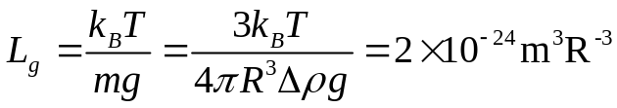
and thus .

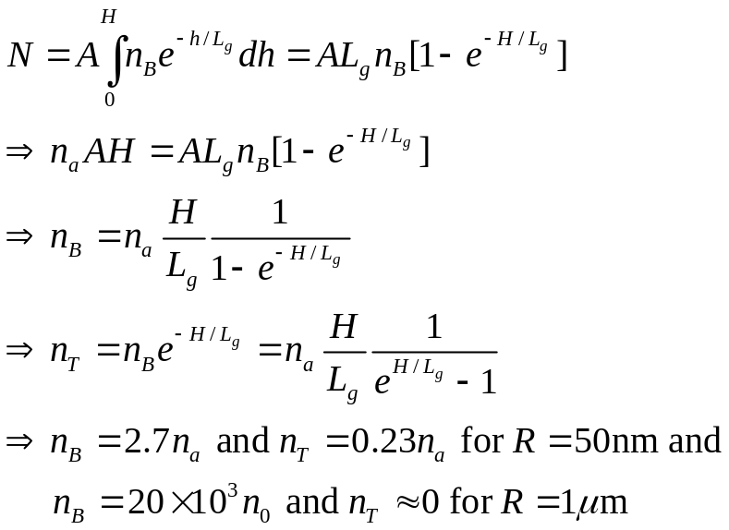(b) Total number 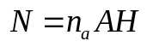(with n_{a} the average density) and
H
Area A
n_{B}
n_{T}
h
Note 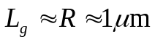 means that at thermal equilibrium in a tube of this suspension there will be hardly any particles a few particle diameters above the bottom of the tube. Almost all particles will thus be sedimented.

(c) In order to establish the concentration gradient, some particles initially at the top of the sample will have to settle to the bottom, Thus some estimate (probably an underestimate) of the time required is the time taken by a particle to sediment a distance H. The time t can be calculated from the sedimentation velocity by
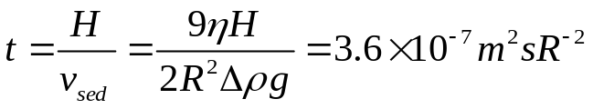
thus t=4.6 years for R=50nm and t=4.2 days for R=1μm.
Note the Boltzmann distribution as used above is only valid if the particles do NOT interact with each other. Otherwise 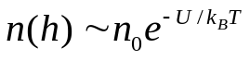 where U is the gravitational p.e. + interparticle interaction.

(4) Peclet number
In one dimension 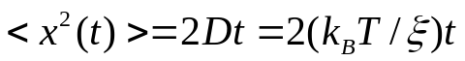. Hence time to diffuse distance R: 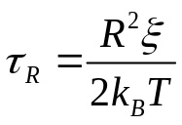
Time to sediment a distance R is: 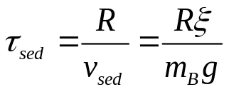
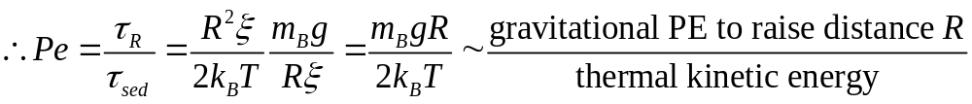

(5) Diffusion equation:
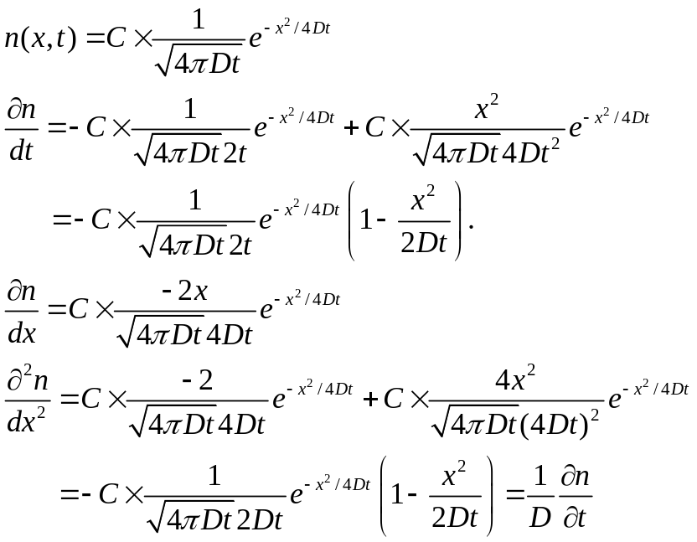

Total number of particles:

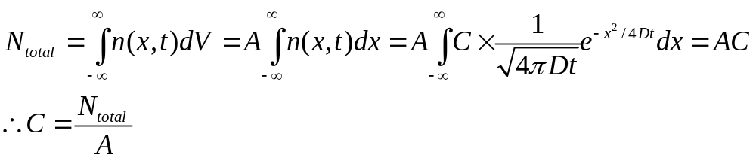

(6) Mean square displacement
The diffusion equation is

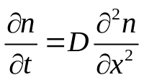

Multiply by x² and integrate:

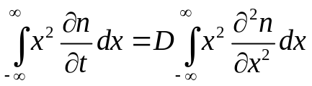
Now, noting that
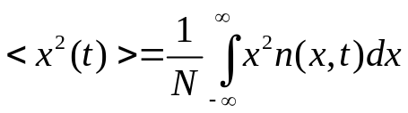
we can write the LHS as
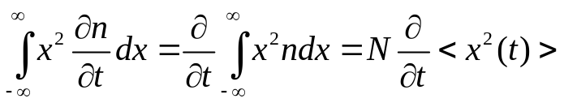
The right hand side can be integrated by parts and, using the fact that as 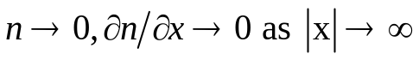

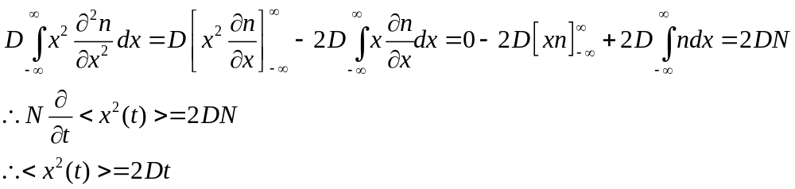

(7) Relaxation time in colloidal suspensions
Based on 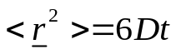, we estimate that 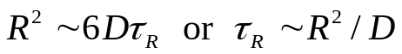. Taking into account the Stokes-Einstein relation 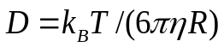, we arrive at
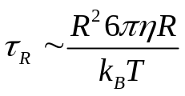
which indicates a very fast increase in 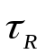as R increases.
For 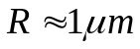we get

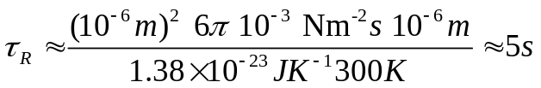

This is seriously long, especially compared to in atomic fluids.

(8) Colloidal Crystals

Upper limit:
Particles per unit cell: 8 in corners (8x 1/8) + 6 in faces (6 x ½=3)
So total of 4 particles with volume 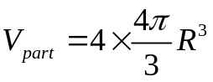
Length of a unit cell: 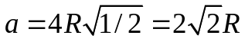

a
Thus volume of a unit cell: 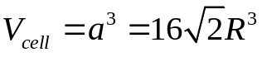
Hence volume fraction: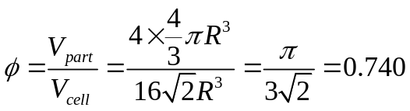

Lower limit

‘swollen’ fcc cell (length a):
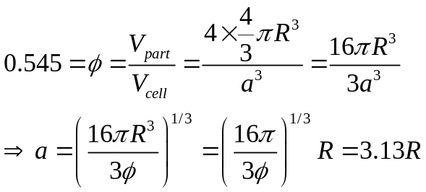

(9) Lagrange’s expression for radius of gyration

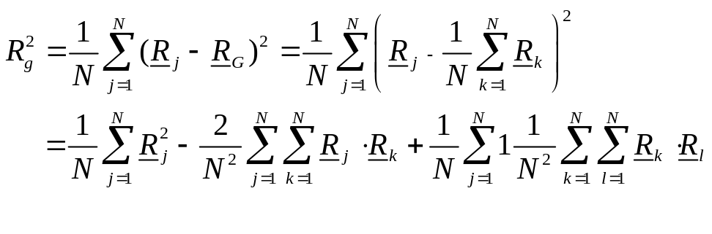
Now, using the hint and changing dummy indices gives
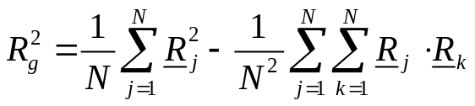
Again using the hint and playing with dummy indices
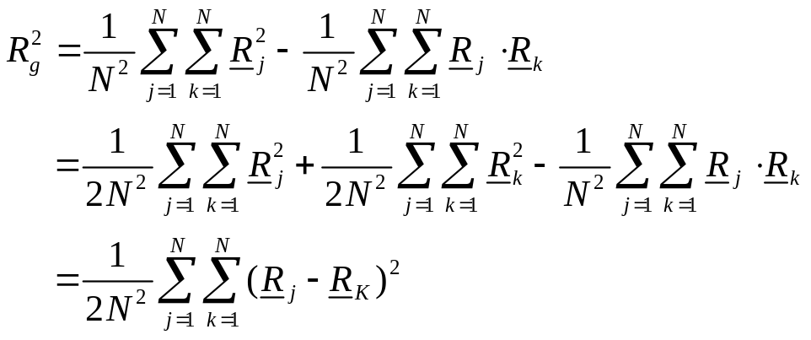

(10) Mean length

For a freely jointed chain, we have from lectures that < R²>=Nb².
Now N=10⁵ and b=4.322Å
Hence, √(<R²>) = √10⁵ × 4.322 ⁼ 1366 Å.

For a fixed bond angle, from notes:
< R²>= Nb²(1+cosθ)/(1−cosθ)
θ=180-108.0°, cosθ= 0.31
Hence, < R²>= 01.9Nb², ⇒√(< R²>)=1.88×10³ Å

(11) Real data

(a)

M (10⁶ g mol^{–1}) | 4.04 1.56 1.20 1.06 0.626 0.394
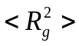 (nm²) | 3260 1210 928 770 484 305
B=(/M)^{1/2} | 0.0284 0.0279 0.0278 0.0270 0.0278 0.0278

with the average value B=0.0278±0.0004 and thus 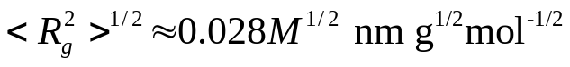

(b)
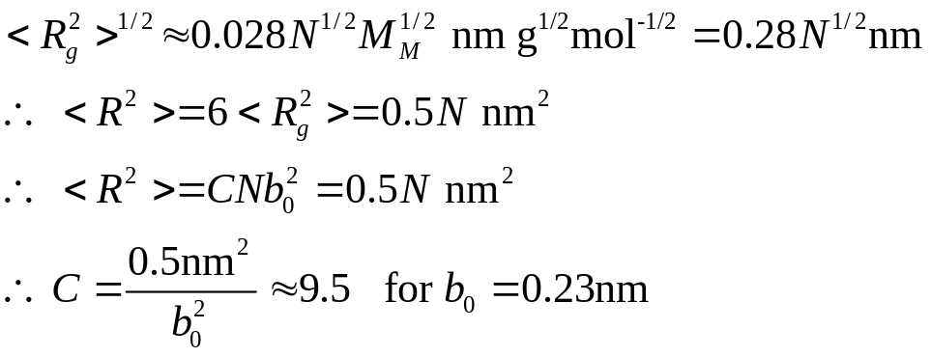
For the freely rotating chain, this leads to
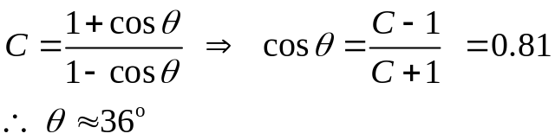
These are fairly typical values of bond angle and persistence length
(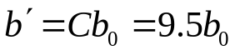)

- From part (a) we get

(d)
The volume occupied by the monomers of one coil is
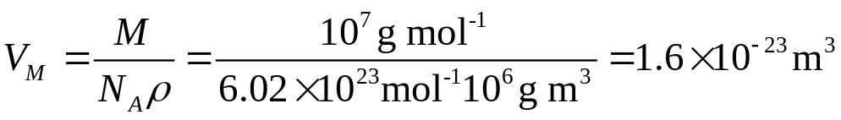
and the volume of the coil is given by
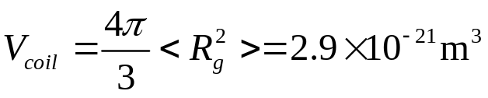
Thus the monomers occupy only about 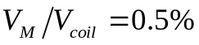 of the volume taken up by the coil. 99.5% of the material inside the coil is solvent!

To reach the overlap concentration c*, we need 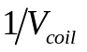molecules and this a monomer volume 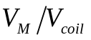 and monomer mass per volume 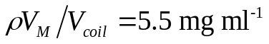. We can also get this value using the equation in the notes:
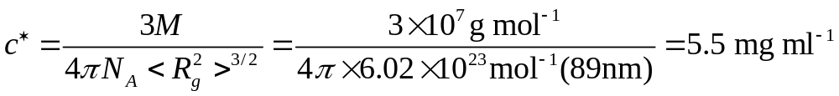
Upon an increase (decrease) in temperature, the solvent becomes a good (poor) solvent and the coil swells (collapses), i.e. 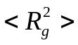 increases (decreases) , and c* thus decreases (increases).

(12) Micelles

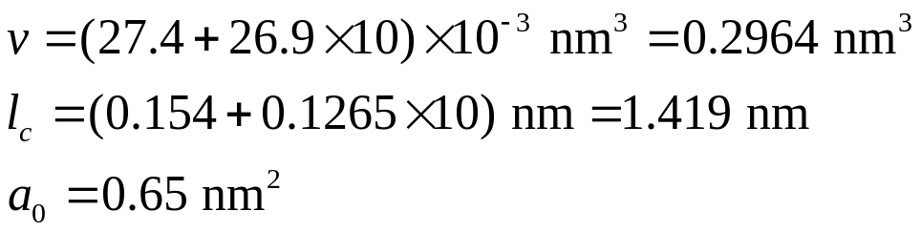Using the results of section 8.2, we can calculate the volume of the hydophobic part and the critical chain length as

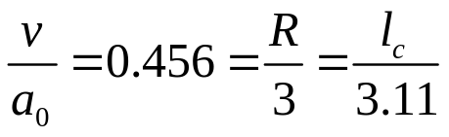Hence
implying spherical micelles of average size R=1.368 nm.
Finally, since 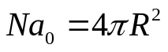, we can calculate that N=36.

(13) Viscosity
Using the Vogel-Fulcher law
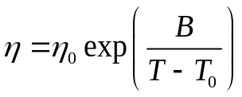

We obtain the graph
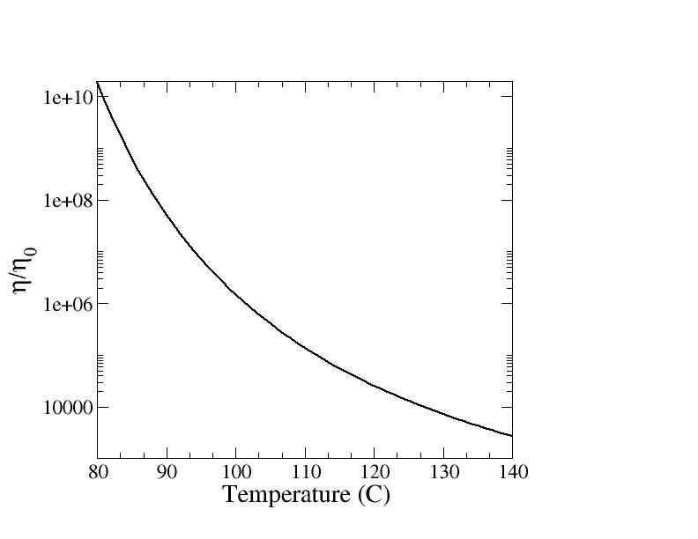
Between T=100°C and T=140°C, the viscosity changes by a factor of about 550.

(14) The glass transition

The glass transition occurs when the system falls out of equilibrium on the experimental timescale τ_{exp}, i.e. when τ_{config}>τ_{exp.}
When τ_{exp}=1000s, the glass transition temperature is 101.4°C. Thus we can calculate

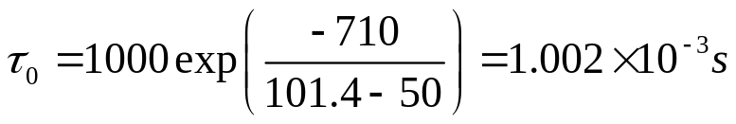
- Rearranging the Vogel-Fulcher law , we find that the glass transition temperature is given by
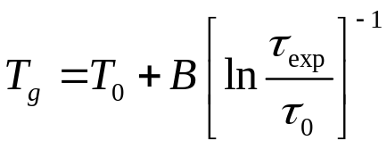 implying that T_{g}=88.5°C.

- For T_{g}=60°C, the Vogel-Fulcher law yields
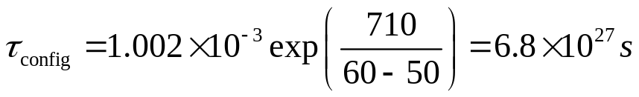
or 2x10²⁰ years.

